Name ___________________________________________ Hour _______ Date _______________
6-4 through 6-6 Review
Directions: Graph the solution of each compound inequality.
- m > -3 and m ≤ 4

- 3 ≥ q or q ≤ 1

Directions: Solve each compound inequality. Then, graph the solution set. Write the solution set in set builder notation.
- -3 ≤ p – 5 < 2

- 2x + 4 ≤ 6 or x ≥ 2x -4

Directions: Solve each open sentence. Then graph the solution set. Write the solution set in { }. For example, {2, -4}.
- │x│ = 7

- │x + 2│ = 4

Directions: Solve each open sentence. Then graph the solution set. Write the solution set in set builder notation.
- │x + 1│ < 4

- │2d - 1│ ≤ 4

Directions: Graph each inequality.
- y < 5
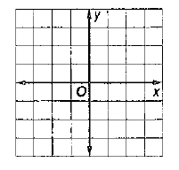

- x ≥ 2

- y ≤ -3x

- 2x – 3y ≤ 6

