Name: ________________________________________________ Date: _____________

6.G.2

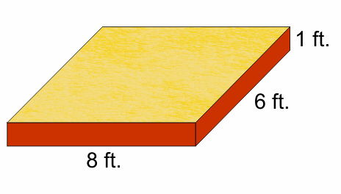
Kaylea’s parents built her a sandbox in their back yard. Kaylea’s parents purchased sand at the local store for $0.60 per cubic foot. How much would it cost to fill the sandbox? Assume the sandbox is filled to the top and leveled. Explain how you found your answer.
9.5 ft.

